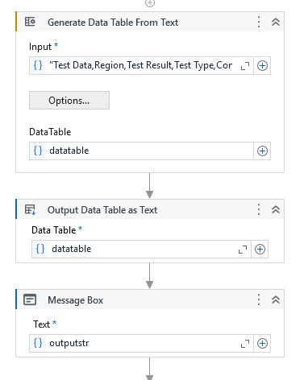 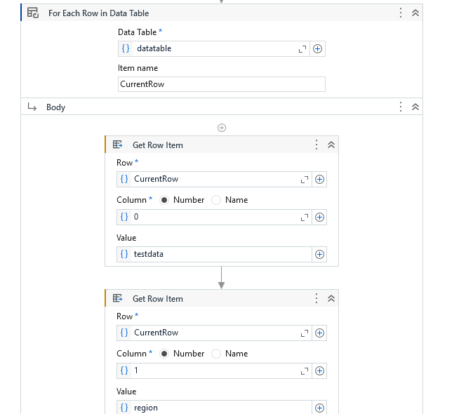

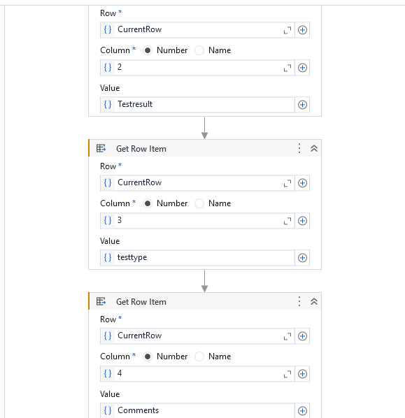 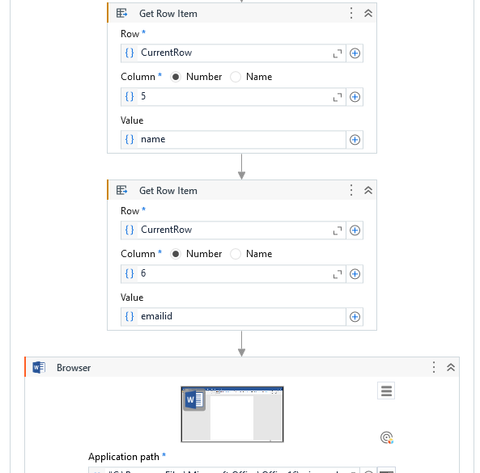

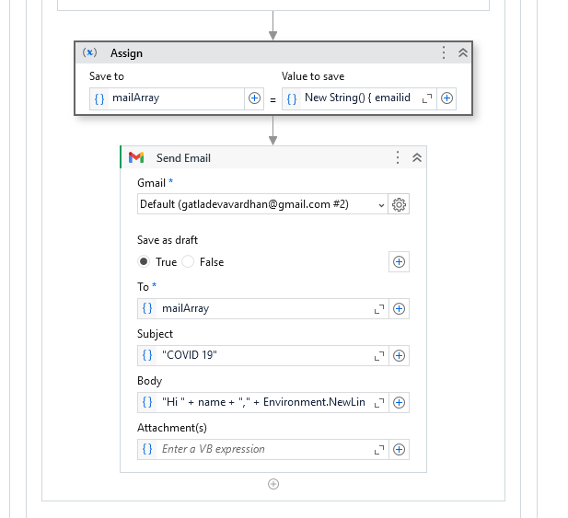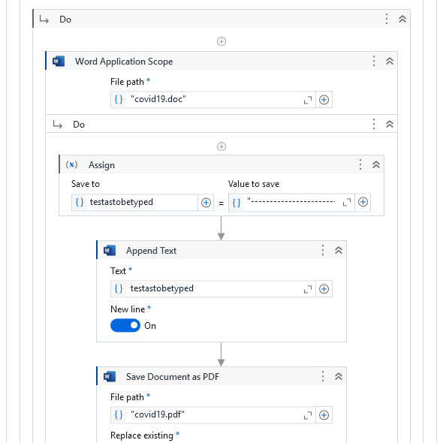

Generate data input "Test Data,Region,Test Result,Test Type,Comments,Name,Email ID

4/22/2025 2:38:08,NYC,Negative,PCR,Isolating,Vardhan,22r01a6615@cmrithyderabad.com"

Assign

"----------------------------------------------------COVID-19 Test Report----------------------------------------------------" & Environment.NewLine & "Patient Name : " & name & Environment.NewLine & "Test Date: " & testdata & Environment.NewLine & "Test Result: " & Testresult & Environment.NewLine & "Test Type: " & testtype & Environment.NewLine & "Comments: " & Comments & Environment.NewLine & "-------------------------------------------------------" & Environment.NewLine & "Name: " & name & Environment.NewLine & "Email ID: " & emailed

Body

"Hi " + name + "," + Environment.NewLine + "Please find the lab report attached." + Environment.NewLine + "Thanks"